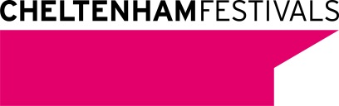
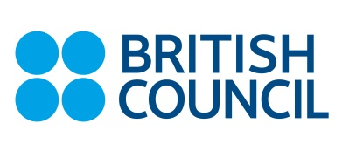

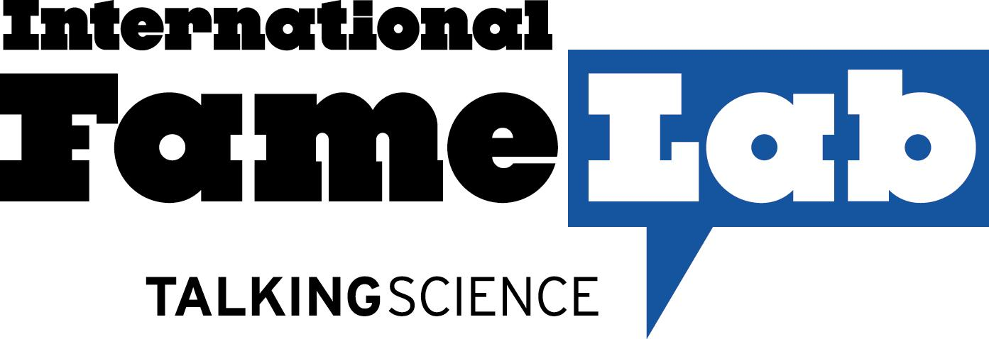

Press release
Who will be 2014’s international face of science?
- Twenty-three science communicators from across the world competing for the 2014 International Fame Lab title
- Judges to include Professors Jim Al-Khalili and Alice Roberts and Martin Horwood, MP for Cheltenham

30th May 2014

23 of the best science communicators from around the globe are heading to The Times Cheltenham Science Festival next week for the seventh FameLab International Finals. The prestigious competition – organised by the British Council and Cheltenham Festivals - aims to discover charismatic, up-and-coming scientists who inspire people to see the world from a new perspective - in just three minutes.

Each contestant will deliver a three-minute presentation on their chosen topic - from the science inside our brains, to the exploration of the stars. Every presentation will be judged according to the golden rule of the 3 Cs: content, clarity and charisma.

Finalists from across five continents will compete to be named as the most exciting, accessible and charismatic science communicator by a panel of expert judges, in front of a packed audience at the festival and tens of thousands watching live around the world. This year’s finals will feature the national winners from Australia, Benelux, Bulgaria, Cyprus, Czech Republic, Egypt, France, Germany, Greece, Hong Kong, Ireland, Italy, Lithuania, Malta, Poland, Portugal, Romania, South Africa, South Korea, Spain, Switzerland, UK and USA.

Since its birth at the Festival in 2005, FameLab has grown into the world’s leading science communication competition. A partnership with the British Council since 2007 has seen the competition go global with more than 5000 young scientists and engineers participating to date in more than 23 different countries.

The 2014 Czech Republic finalist emerged from tough competition to win the national final, and will be competing in the first semi-final.

Matyáš Krijt is a PhD student at the 1st Faculty of Medicine at Charles University in Prague. When he was young he wanted to be a professional ice-hockey player, then an actor and ultimately he decided to become a doctor. His current research focuses on detecting disorders in the synthesis of purines – the basic building blocks of our DNA – in newborns. Symptoms of such disorders include delayed development, seizures and autism manifestations. More accurate diagnostic methods could lead to better treatment from a very young age. In his free time Matyáš enjoys playing ice-hockey, hiking, cycling and having a beer in the pub with his friends.

Professor Russell Foster FRS, Chair of The Times Cheltenham Science Festival said “World class science not only excites our thirst for knowledge but underpins economic growth in every nation, and there has never been a more important time to communicate science to all sectors of society across the globe. FameLab provides the ideal crucible for scientists from around the world to learn and forge their ability to communicate science and convey the thrill of undertaking scientific research. I have been profoundly impressed by the atmosphere of good will and cooperation that FameLab generates between researchers from very different nations, cultures and backgrounds. The torch of international science communication burns very bright at FameLab!”

John Worne, Director of Strategy at the British Council, added: “The British Council exists to bring people together and science is the embodiment of international collaboration at its very best. You only have to look at institutions like CERN and the UK’s great research universities to find hugely committed people from all over the world working together in pursuit of a greater understanding of life and the universe. But science needs more leaders, policymakers - and the public - understanding its method, discoveries and achievements. We need more people like Professor Brian Cox; scientists who can take complex ideas and make them simple and compelling for us all. Famelab is all about scouring the world for the young scientists who can do this. And the best of the best are coming to Cheltenham to share their passion with the UK.”

The competition will be judged by international panels of science communication experts, including:

- Professor Jim Al-Khalili, OBE is a British scientist, author and broadcaster. He is a professor of Physics at the University of Surrey where he also holds a chair in the Public Engagement in Science. He is president of the British Humanist Association.
- Martin Horwood, MP for Cheltenham, chair of the Liberal Democrat parliamentary committee on international affairs.
- Professor Mark Lythgoe, founder and Director of the UCL Centre for Advanced Biomedical Imaging, He has given over 200 invited public lectures, and regularly presents programmes on radio and television.
- Dr Phil Manning, Reader in Palaeobiology and Head of the Palaeontology Research Group (PRG) at the University of Manchester. He has authored both children and popular science books and is a regular contributor to public speaking programs around the world.
- Jennifer Ouellette Los Angeles-based science writer who has had several books published and articles printed in a range of popular publications such as Discover Magazine, New Scientist, Physics Today and The Wall Street Journal.
- Maggie Philbin, British radio and television presenter with credits including SwapShop, and popular science programmes Bang Goes the Theory and Tomorrow’s World.
- Professor Alice Roberts, Professor of Public Engagement in Science at the University of Birmingham, author, researcher and presenter. She has presented a range of programmes on BBC2 including Coast, Wild Swimming, The Incredible Human Journey, Origins of Us, and Prehistoric Autopsy
- Wendy Sadler, Director of Science Made Simple and recipient of the EU Descartes Laureate for her innovative work in science communication.
- George Zarkadakis, Greek novelist, playwright and science journalist who studied Systems Engineering at City University, London and has a PhD in Artificial Intelligence.

The number of participating FameLab countries has doubled in the past few years. This means that this year there will be two semi-finals, taking place on the Tuesday 3 and Wednesday 4 of June, to select the contestants that will compete at the grand final on Thursday 5 June at The Times Cheltenham Science Festival. Tickets are available at http://www.cheltenhamfestivals.com/science/whats-on/list

Communicating science accessibly and attractively is an ever-growing priority for researchers worldwide. FameLab helps young scientists acquire valuable skills to communicate their work with passion to a non-scientific audience. By doing so, researchers do not merely change the common stereotype of the scientist as “the geek in the white lab coat”, but also justify public funding for their research.

For the first time, both the semi-finals and the final will be live streams, and you can watch all at www.famelab.org, the actual links are below. You can also keep up with all of the action by following @FameLabUK and @CheltFestivals, and join the conversation using #FameLab.The audience will be able to vote for their favourite finalist.

Semi-Final 1: Tuesday 3 June , livestream: https://www.youtube.com/watch?v=jLnvRPZtdsc
Semi-Final 2: Wednesday 4 June, 08.30-10pm, livestream: https://www.youtube.com/watch?v=pYnELYyh0_I
Final: Thursday 5 June, 08.30-10.15, livestream: https://www.youtube.com/watch?v=rs32UWuLzys

Notes to the Editor

FameLab® is an initiative of the Cheltenham Festivals in the UK. The British Council has license to deliver the competition in 25 countries overseas. NASA has license to deliver the competition in the USA.

Semi-Final 1: Tuesday 3 June, 08.30-10pm, Winton Crucible, The Times Cheltenham Science Festival, Cheltenham Town Hall & Imperial Gardens, Cheltenham, GL50 1QA
Semi-Final 2: Wednesday 4 June, 08.30-10pm, Winton Crucible, The Times Cheltenham Science Festival, Cheltenham Town Hall & Imperial Gardens, Cheltenham, GL50 1QA
Final: Thursday 5 June, 08.30-10.15, EDF Energy Arena, The Times Cheltenham Science Festival, Cheltenham Town Hall & Imperial Gardens, Cheltenham, GL50 1QA

The first semi-final will see the winners from South Africa, Italy, Spain, Czech Republic, Bulgaria, Switzerland, USA ,South Korea, Portugal, Romania and Cyprus fight it out. Whilst the second semi-final will see Malta, Egypt, Greece, Ireland, Lithuania, Benelux, Germany, France, United Kingdom, Hong Kong, Australia and Poland compete for their places in the Final.

The judging panel will award first and runner-up prize. There will also be an audience vote winner selected by those watching live. Following the success of previous years, there will also be a special award – the International Alumni Award, voted for Eurovision-style by FameLabbers from around the world.

The Times Cheltenham Science Festival – 3-8 June 2014
The Times Cheltenham Science Festival is a six-day celebration of science, engineering and the arts and is produced by Cheltenham Festivals. A rare opportunity for the public to come face-to-face with around 300 of the world's leading scientists and thinkers, the Festival annually issues in excess of 31,000 tickets whilst the free interactive Discover Zone and other free events and exhibitions attracts over 17,000 visitors. The six day Festival promises a mix of serious debate, live experiments and surprising discoveries all based at Cheltenham Town Hall. http://www.cheltenhamfestivals.com/science/

The British Council creates international opportunities for the people of the UK and other countries and builds trust between them worldwide. We are a Royal Charter charity, established as the UK’s international organisation for educational opportunities and cultural relations. Our 7000 staff in over 100 countries work with thousands of professionals and policy makers and millions of young people every year through English, arts, education and society programmes. A quarter of our funding comes from a UK government grant, and we earn the rest from services which customers pay for, education and development contracts we bid for, and from partnerships. For more information, please visit: www.britishcouncil.org. You can also keep in touch with the British Council through http://twitter.com/britishcouncil and http://blog.britishcouncil.org.

Biographies and photos of this year’s contestants and past international winners available upon request

